Jack Crawford

PIG!

Code:

//pig.java

import java.util.Scanner;

import java.util.Random;

public class pig

{

public static void main (String[] args)

{

Random dices = new Random();

Scanner input = new Scanner(System.in);

System.out.println("Welcome to PIG, the most \"fun\" \"game\" in the world!");

System.out.println("––––––––––––––––––––––––––––––––––––––––––––––––––––––––");

int dice_1, dice_2, together, round_count = 1, total_points = 0, round_points = 0;

boolean round_active = true;

boolean continue_game = true;

boolean automation = false;

int continue_or_nah = 0;

//user play stuff

//System.out.print("Automate the game or play yourself? (enter 1 for automation) > ");

//if (input.nextInt() == 1) {

// automation = true;

//}

//input.nextLine();

//monte carlo stuff

//uncomment to try

automation = true;

int monte_count = 0;

double avg_rounds = 0.0;

while (monte_count <= 1000) {

round_count = 1;

while (continue_game) {

System.out.println("\nRound " + round_count + ":");

while (round_active) {

dice_1 = dices.nextInt(5) + 1;

dice_2 = dices.nextInt(5) + 1;

together = dice_1 + dice_2;

if (together == 2) {

round_active = false;

round_points = 0;

total_points = 0;

System.out.println("You rolled snake eyes, your score is now 0. Sorry!");

} else {

if (dice_1 == 1 || dice_2 == 1) {

round_points = 0;

round_active = false;

System.out.println("On round " + round_count + ", you rolled a one, reset round");

} else {

round_points = round_points + together;

System.out.println("You rolled a " + together);

System.out.println("Round points: " + round_points);

System.out.println("Total points: " + total_points);

if (!automation) {

System.out.print("Keep going? (Hit 1 to end the round, anything else to continue.) > ");

continue_or_nah = input.nextInt();

input.nextLine();

} else {

if (round_points >= 16) {

continue_or_nah = 1;

} else {

continue_or_nah = 0;

}

}

if (continue_or_nah == 1) {

total_points = total_points + round_points;

round_points = 0;

round_active = false;

} else {

round_active = true;

}

}

}

}

if (total_points >= 100) {

continue_game = false;

System.out.println("You win! Total score: " + total_points);

System.out.println("Total rounds: " + round_count);

monte_count ++;

total_points = 0;

avg_rounds += round_count;

} else {

round_active = true;

round_count ++;

}

}

round_count = 1;

continue_game = true;

}

avg_rounds = avg_rounds / 1000.0;

System.out.println(avg_rounds);

}

}

Output:

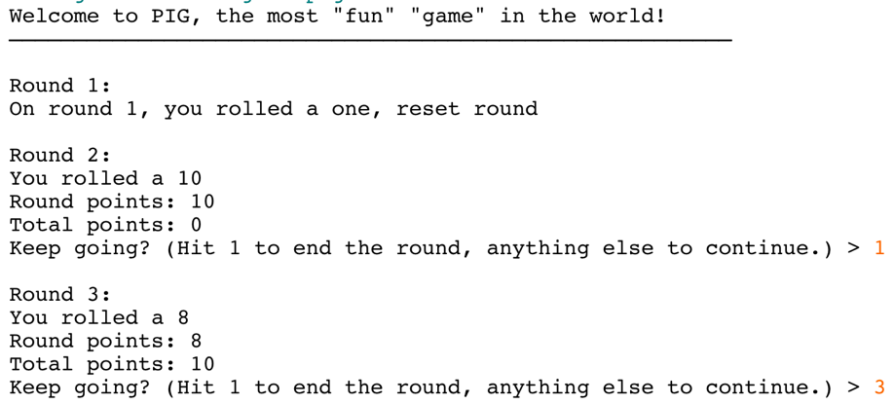

etc. etc.

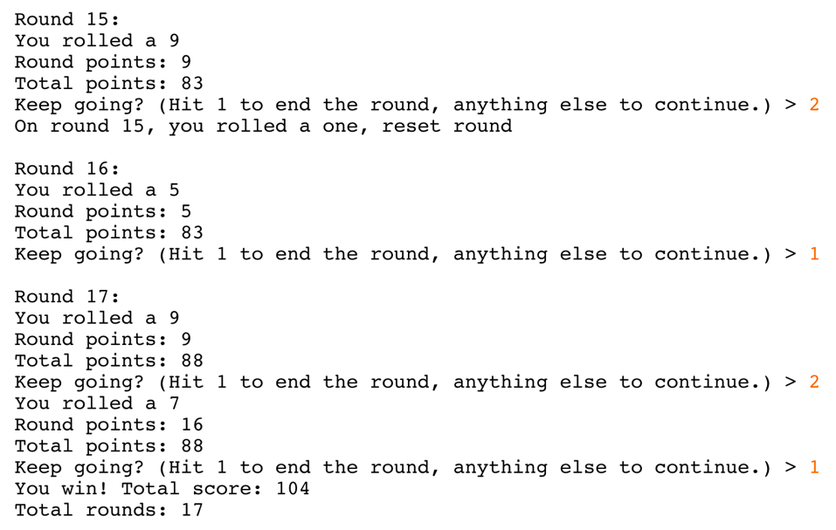

Approx: 30 minutes

Monte Carlo: 37*

* I added an automation mode and ran it for a couple thousand games, if you end rounds with a score of 16 or more, the average

number of rounds is around 37